Water Vascular System of Asteroidea:
The water vascular system is a modified part of coelom and it consists of a system of sea- water filled canals having certain corpuscles. It plays most vital role in the locomotion of the animal and comprises madreporite, stone canal, ring canal, radial canal, polian vesicles, Tiedeman’s bodies, lateral canals and tube feet.
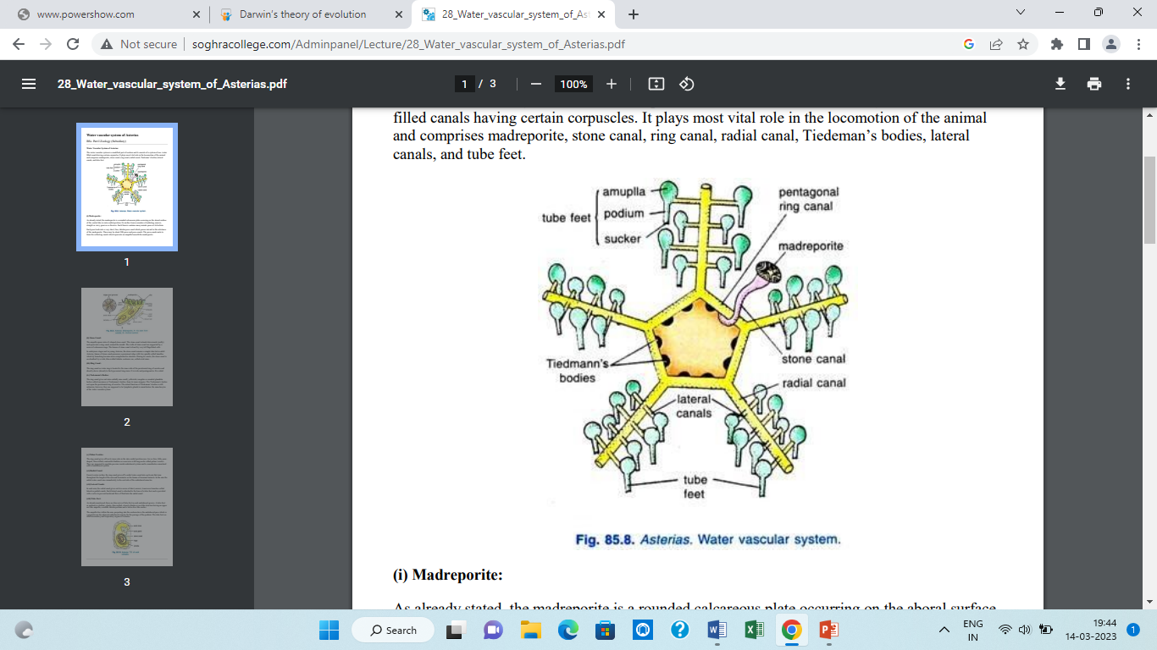

Fig. Water Vascular System in Asteroidea
(i) Madreporite: As already stated, the madreporite is a rounded calcareous plate occurring on the aboral surface of the central disc in inter-radial position. Its surface bears a number of radiating, narrow, straight or wavy grooves or furrows. Each furrow contains many minute pores at its bottom. Each pore leads into a very short, fine, tubular pore canal which passes inward in the substance of the madreporite. There may be about 200 pores and pore-canals. The pore-canals unite to form the collecting canals which open into an ampulla beneath the madreporite.
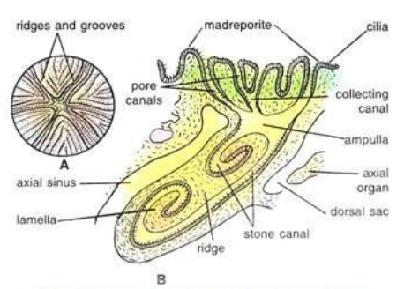

Fig. Asterias: Madreporite. A.- as seen from outside. B.- Vertical section.
(ii) Stone Canal: The ampulla opens into a S-shaped stone canal. The stone canal extends downwards (orally) and opens into a ring canal, around the mouth. The walls of stone canal are supported by a series of calcareous rings. The lumen of stone canal is lined by very tall flagellated cells. In embryonic stages and in young Asterias, the stone canal remains a simple tube but in adult Asterias, lumen of stone canal possesses a prominent ridge with two spirally rolled lamellae which by branching become more complicated in structure. During its course, the stone canal is en-sheathed by a wide, thin-walled tubular coelomic sac, called axial sinus.
(iii) Ring Canal: The ring canal or water ring is located to the inner side of the peristomial ring of ossicles and directly above (aboral) to the hypo neural ring sinus. It is wide and pentagonal or five sided.
(iv) Tiedemann’s Bodies: The ring canal gives out inter-radially nine small, yellowish, irregular or rounded glandular bodies called racemose or Tiedemann’s bodies, from its inner margins. The Tiedemann’s bodies rest upon the peristomial ring of ossicles. The actual function of Tiedemann’s bodies is still unknown, however, they are supposed to be lymphatic glands to manufacture the amoebocytes of the water vascular system.
(v) Polian Vesicles: The ring canal gives off on its inner side in the inter-radial position one, two or four, little, pearshaped, thin-walled, contractile bladders or reservoirs with long necks called polian vesicles. They are supposed to regulate pressure inside ambulacral system and to manufacture amoeboid cells of ambulacral system.
(vi) Radial Canal: From its outer surface the ring canal gives off a radial water canal into each arm that runs throughout the length of the arm and terminates as the lumen of terminal tentacle. In the arm the radial water canal runs immediately to the oral side of the ambulacral muscles.
(vii) Lateral Canals: In each arm, the radial canal gives out two series of short, narrow, transverse branches called lateral or podial canals. Each lateral canal is attached to the base of a tube foot and is provided with a valve to prevent backward flow of fluid into the radial canal.
(viii) Tube Feet: As already mentioned, there are four rows of tube feet in each ambulacral groove. A tube foot or podium is a hollow, elastic, thin-walled, closed cylinder or sac-like structure having an upper sac-like ampulla, a middle tubular podium and a lower disc-like sucker. The ampulla lies within the arm, projecting into the coelom above the ambulacral pore which is a gap between the adjacent ambulacralossicles for the passage of the podium. The tube feet are chief locomotory and respiratory organs of Asterias.
Functions of the water vascular system :
The Water Vascular system has three main functions . They are as follows :
1. Locomotion
2. Food Capture
3. Attachment
1. Locomotion: The water vascular system sets up a hydraulic pressure mechanism which brings about the locomotion. The inner wall of the water vascular canals is provided with cilia. The beating of the cilia causes the seawater to enter through the madreporite. Finally, the seawater reaches the tube feet and their ampullae. The ampullae contract; the valves at the junction of the lateral canals and tube feet, prevent the flow of water into radial canals. The water is forced into the podia. The podia are elongated and protected out through the ambulacral groove. Then the suckers are applied to the substratum. The tube feet now contract & push the body forward. The water from the tube feet is pushed into the ampulla. Hence, the tube feet shorten. The suckers are released. Then the ampulla contracts & the whole process is repeated.
2. Food capture : The tube feet are used to capture the prey . The suckers are used to open the shells of molluscs.
3. Attachment : The star fish can be attached to the rocks by the tube feet.

