Population Growth Forms (Models)
Populations have characteristic patterns of increase which are called population growth forms. The two models of population growth used to describe the rate of change in the size of a population over time are:
- Exponential growth form (J-shaped growth form):
In this form, population density increases rapidly in exponential or geometric fashion and then stops abruptly as environmental resistance or any other limit becomes effective more or less suddenly.
If in a population of size N, the birth rate is represented as ‘b’ and death rate as‘d’, then the increase or decrease in N during a unit time period t (dN/dt) will be
dN/dt = (b – d) × N
Let (b–d) = r, then
dN/dt = rN
The ‘r’ in this equation is called the ‘intrinsic rate of natural increase’ and is a very important parameter chosen for assessing impacts of any biotic or abiotic factor on population growth.
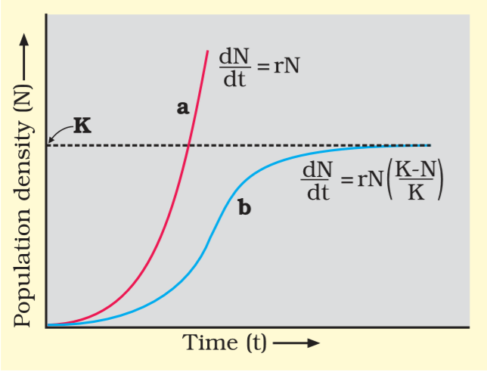

Fig: Population growth curve
a - when responses are not limiting the growth, plot is exponential,
b - when responses are limiting the growth, plot is logistic,
K - carrying capacity
The above equation describes the exponential or geometric growth pattern of a population and results in a J-shaped curve when we plot N in relation to time. The integral form of the exponential growth equation can be derived as:
N_{t} = N₀ e^{rt}
Where,
N_{t} = Population density after time t
N₀ = Population density at time zero
r = intrinsic rate of natural increase
e = the base of natural logarithms (2.71828)

*(In J-shaped growth form there may be no equilibrium level, but the limit on N represents the upper limit imposed by the environment)
- Logistic growth form (S-shaped or Sigmoid growth form):
In this form, the population increases slowly at first (positive acceleration phase), then more rapidly (logarithmic phase), but it soon slows down gradually as the environmental resistance increases percentage-wise (negative acceleration phase) until a more or less equilibrium level is reached and maintained. A plot of N in relation to time (t) results in a sigmoid curve. This type of population growth is called Verhulst-Pearl Logistic Growth and is represented by the following equation:
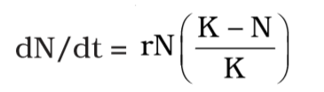

Where,
N = Population density at time t
r = Intrinsic rate of natural increase
K = Carrying capacity
The upper limit beyond which no major increase can occur is the upper asymptote of the sigmoid curve and is represented by the constant ‘K’ (Carrying capacity).
*Since resources for growth for most animal populations are finite and become limiting sooner or later, the logistic growth model is considered a more realistic one.

--©©©©©©©©©©©©--

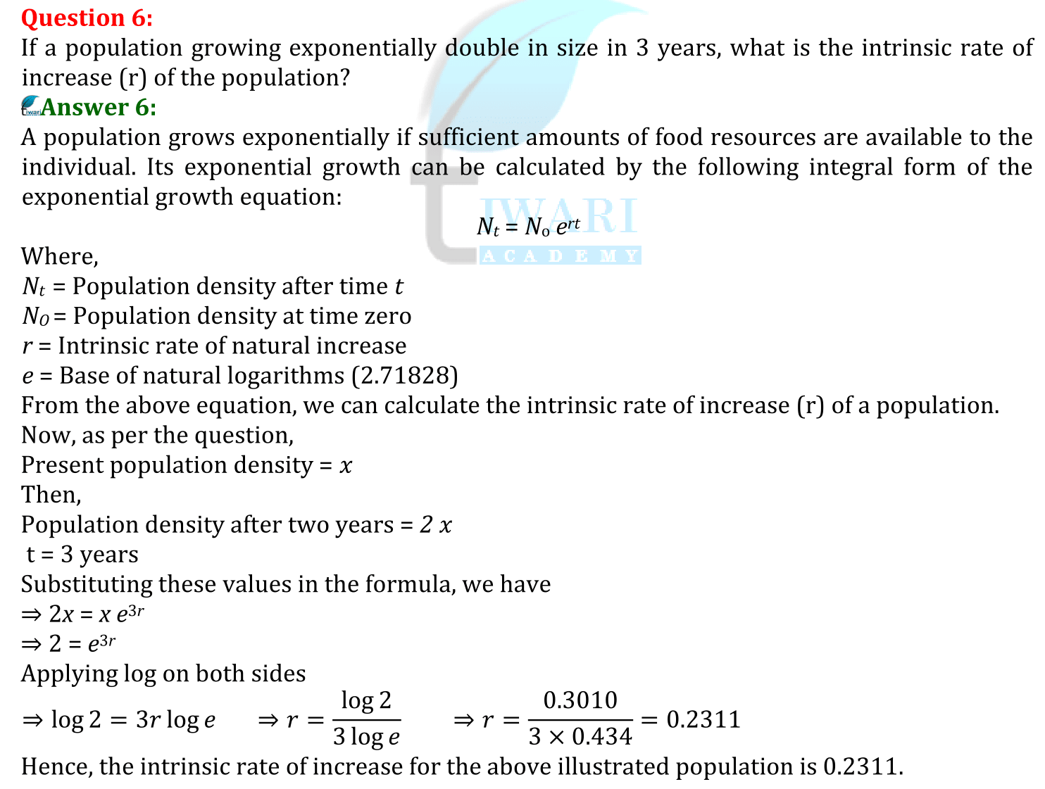
Examples:

