Gause’s Principle with laboratory and field examples…..
Background: Georgii Frantsevich Gause (1910– 1986), a Russian biologist, published his “Principle of Competitive Exclusion” in 1932 based on experimental work with mixed cultures of yeast and the protozoa Paramecium.

Gause’s ‘Competitive Exclusion Principle’ states that two species with identical niches cannot coexist indefinitely. i.e., two closely related species competing for the same resources cannot co-exist indefinitely and the competitively inferior one will be eliminated eventually.
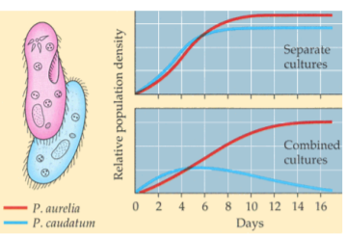
Laboratory example:
In his classic experiment Gause (1934) first grew Paramecium caudatum and Paramecium aurelia in separate cultures (yeast medium) and found that each species grew in numbers according to the logistic equation. However, P. aurelia grows in numbers more quickly than P. caudatum and shows more individuals in the same volume of culture medium. But when he grew the two species together in same culture volume, he observed that initially both species grew in numbers, but eventually P. caudatum declined and became extinct.
Fig: When grown alone, both species of Paramecium show logistic growth. When grown together, the better competitor drives the other to extinction.
It is because P. aurelia population simply had a more
rapid growth rate (r) than P. caudatum and thus “out-competed “them under the existing condition of limited food resource. This experiment clearly suggests that reduced resource supply increase the intensity of competition.

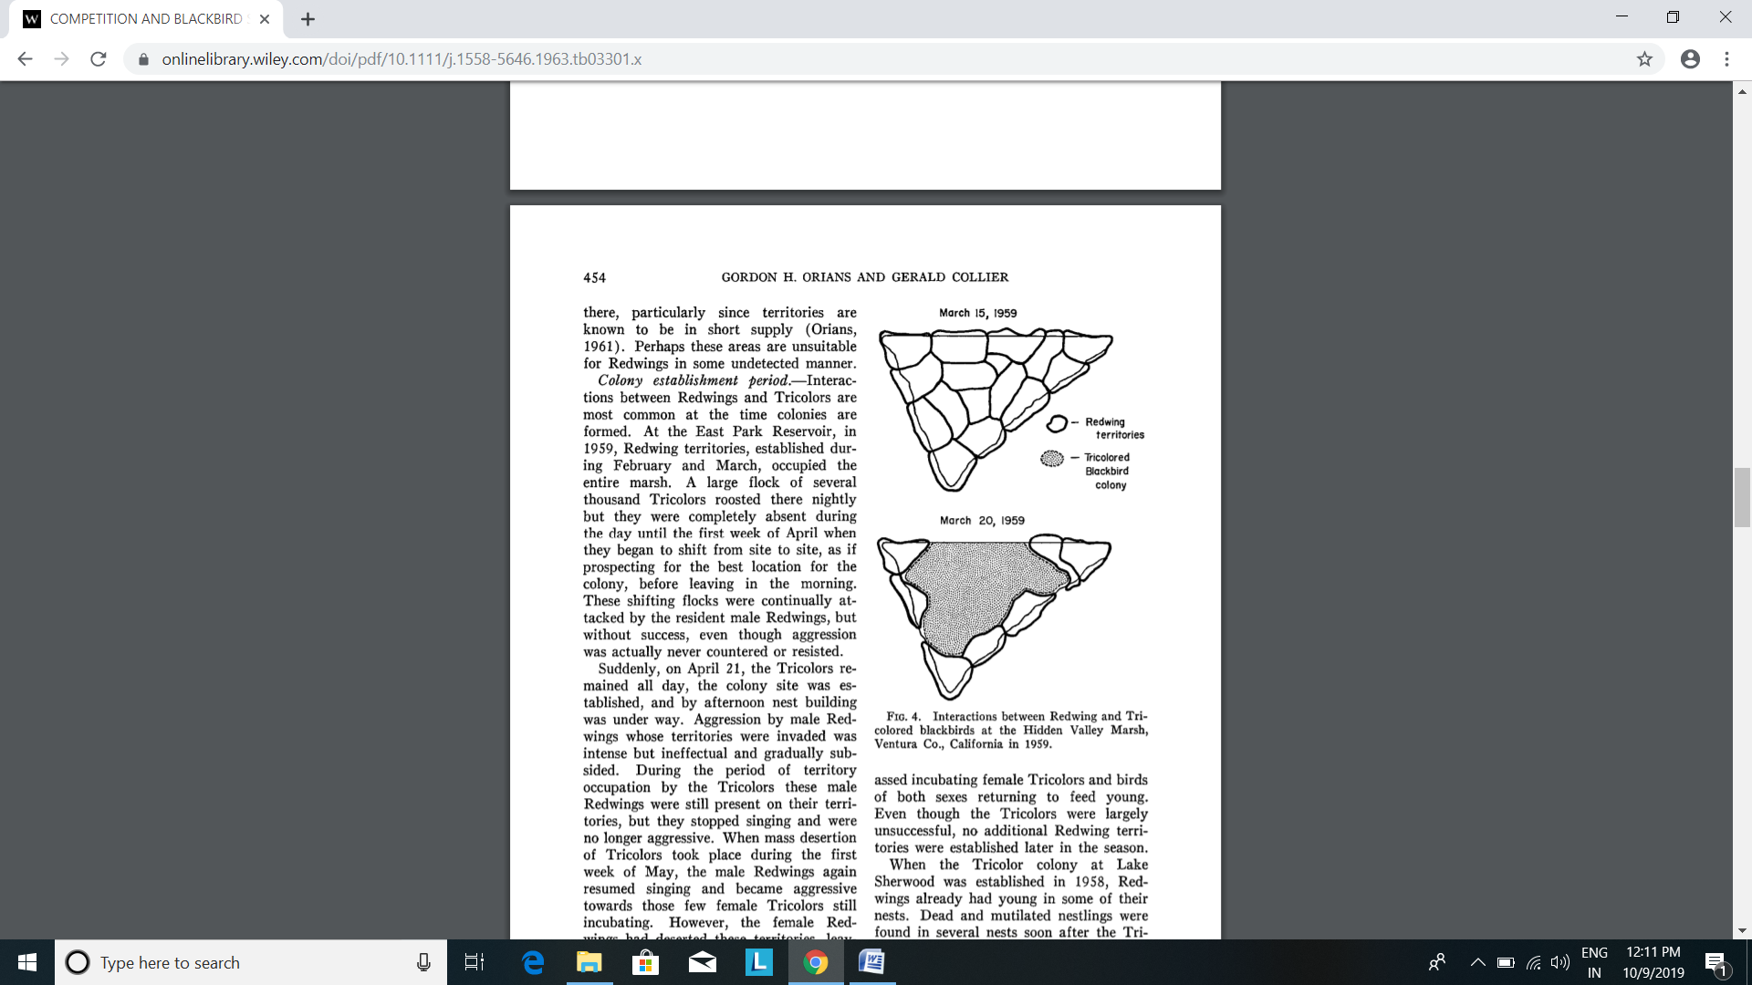
Field example:
Displacement of Red-winged Blackbird by Tricolored Blackbirds:
Observation of competitive exclusion was recorded with two species of Blackbirds in California. Red-winged Blackbirds had fully occupied a marsh with established nesting territories during February and early March. Then suddenly a colony of Tricolored Blackbirds invaded, leaving only a few intact redwinged territories around the margin. As a rule competitive exclusion is achieved more frequently and efficiently through interference, than through exploitation. There is an evolutionary trend among birds to establish mechanism of interference, such as song, display and chasing behavior in the defence of territories. ( Miller, 1968)
Exception to competitive exclusion principle:
More recent studies point out that species competing for the same resource might evolve mechanisms that promote co-existence rather than exclusion. The species can co-exist by reducing competition via ‘resource partitioning’
MacArthur (1958) showed that five closely related species of insectivorous warblers living on the same tree were able to avoid competition and co-exist by choosing different feeding time and foraging patterns. He concluded that the birds are partitioning a limiting resource (their supply of insects) and, in the process, occupying different niches.
Character displacement:
Character displacement occurs when similar species that live in the same geographical region and occupy similar niches differentiate in order to minimize niche overlap and avoid competitive exclusion. Several species of Galapagos finches (Darwin’s finches) display character displacement. Darwin observed that each closely-related species of finch differs in beak size and beak depth, allowing them to coexist in the same region since each species eats a different type of seed: the seed best fit for its unique beak. The finches with the deeper, stronger beaks consume large, tough seeds, while the finches with smaller beaks consume the smaller, softer seeds.

--€€€€€€€€€€€€€€€--

